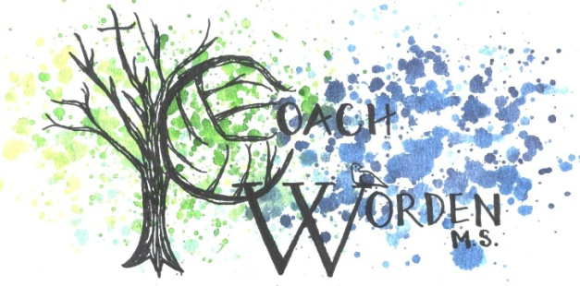
Larimore High School Mrs. Jamie Worden
300 Booth Ave 1907 Willow Drive
Larimore, ND 58251 Grand Forks, ND
(701) 343-2366 Rm 301 (701) 709-0083 Jamie.Worden@larimoreschools.com jlworden1@gmail.com
Volleyball Website: https://sites.google.com/site/coachwordensvolleyballwebsite/
Art Website: https://sites.google.com/site/wordenswonderwall/

Student’s will need: $5 (just lunch) $15 (with bowl & lunch)
*If parents/students decide to purchase a bowl/lunch please turn in money no later than November 11th . Bus will leave on November 18th at 10:30am from the High School and return by 2:15pm.
*We will also visit the North Dakota Museum of Art to view exhibitions “BARTON BENES PERIOD ROOM: 21ST CENTURY ARTIST STUDIO” & “JAMES ROSENQUIST: AN EXHIBITION CELEBRATING HIS 80TH BIRTHDAY”
Dear Parents & Students

St. Joseph’s is a local organization that includes a Thrift Store, Food Pantry and Emergency Assistance Program. Since its inception, St. Joseph’s has been committed to fighting hunger. In the past few years, we have seen a significant increase in the number of families and individuals that are in need of food. For this reason St. Joseph’s has started a fundraising campaign that would be geared specifically towards fighting hunger.

The Empty Bowl Project is a fundraising event that allows the opportunity to share and educate the community about hunger, who is affected and how the community can help.
St Joseph’s is hosting their yearly Empty Bowl Event. Many bowls are being created and painted for this event.

In 1990 a high school art teacher in Michigan helped his students solve a problem. They were searching for a way to raise funds to support a food drive. What evolved was a class project to make ceramic bowls for a fund raising meal. Guests were served a simple meal of soup and bread, and were invited to keep the bowl as a reminder of hunger in the world. By the following year the originators had developed this concept into Empty Bowls, a project to provide support for organizations that fight hunger.

The basic idea for Empty Bowls is simple. Participants create ceramic bowls, and then serve a simple meal of soup and bread. Guests choose a bowl to use that day and to keep as a reminder that there are always Empty Bowls in the world. In exchange for meal and a bowl, the guest gives a suggested minimum donation of fifteen dollars. The proceeds are then used to fight hunger and in this case, will be used locally in Grand Forks.

It is our sincere hope that you will join us in making the Eighth Annual Empty Bowl Event in Grand Forks a major success. The event is planned for Monday November 18, 2013 at St Michaels School gym from 11:00 AM to 7:00PM. Please feel free to call us with any questions. 795-8614
We look forward to hearing from you!

Sincerely,

The Empty Bowl Committee

Please see reverse side for information on purchasing bowls.

Students may purchase the bowl that they have painted. We anticipate about 1500 bowls to be painted this year alone; therefore, we have created a process for students who wish to purchase their own bowls in advance.

- Students may purchase the bowl they have painted for $15.00. (DUE NOVEMBER 11th). If you would like to still attend the field trip and eat students will need to pay $5.

- All bowls must be paid for on the day of the painting.

- Students will be asked to give a description of the bowl so that it may be identified after it is glazed and fired. We ask that students initial the bowls on the bottom underside of the bowl using black paint and give as complete and detailed description as possible. Please do not include any dates or year. This will ensure that each and every student gets their bowl back without confusion.

- All bowls not paid in advance will be available at the Empty Bowl Event for $15.00.

- Bowls will not be arranged by groups. All bowls will be on display for purchase on a first come first serve basis. Essentially, bowls not purchased in advance will be mixed in with the other 1000 bowls and need to be found. (Some of you may be familiar with the expression, “needle in a haystack” )

- All bowls not purchased will be available to the general public. Remember, if you chose not to purchase your bowl, it will go home with someone else as a reminder of all the empty bowls in the community!! It might even become someone’s Holiday or birthday gift!

- Thank you for your support of this project—your participation is greatly appreciated.

Students will be painting bowls on November 4th 2013.

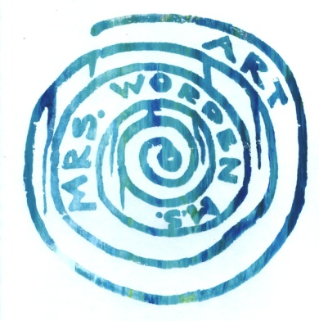

Sincerely,
Mrs. Jamie Worden M.S.
Art Educator
Head Volleyball Coach

