****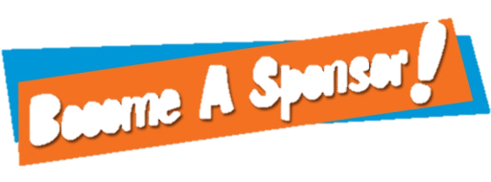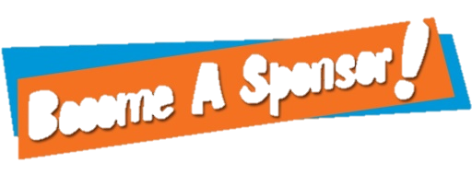

Art Club is for students who are interested in the arts; they do not need to be enrolled in an art class. In Art Club, we do monthly craft days, murals, making items for holiday events, art contests, culinary experiences, and our own awesome Spring Night of the Arts! The art club consists of students from grade 7- 12. We elect officers including President, Vice-President, Treasurer, Advertiser, and Photographer.   
          Art club is a great organization. The club provides students with hands-on projects and a place to talk about what is happening in the art world.  We not only have planned field trips to local events, galleries, and museums, but also coordinate the Fine Arts for various tours in the U.S., Canada, and Europe. This is where we need YOUR help! Artists participate in fundraisers through the school year such as 50/50 Raffle at LHS sporting events, selling Christmas Wreaths, and Butterbraids.  We are also asking local businesses for sponsorship to support our 2017 Art Tour to NEW YORK CITY!!

**Art Club   
Sponsorship Registration**

**Platinum Sponsor…$500**

* 2 Free Admission Tickets for Spring Night of the Arts!
* Company logo advertisement on the back of our club t-shirts
* Free Club T-shirt
* Sponsorship Certificate & Club Photo

Business Name:_________________  
Contact Name:_________________  
Address: ______________________  
City, State, Zip: _________________  
Phone:________________________ Email:_________________________

Platinum Sponsor…$500  
  Gold Sponsor……….$250  
  Silver Sponsor……...$100  
  Other________

*Send logo to Mrs Worden by August 15, 2016 to be included on the club t-shirts: [jlworden1@gmail.com](mailto:jlworden1@gmail.com)

**Make checks payable to:**  
LHS Art Club  
**Mail Form & payment to:**  
LHS ATTN: Mrs Worden  
300 Booth Ave  
Larimore, ND 58251

* Company logo advertisement on the back of our club t-shirts
* Free Club T-shirt
* Laminated Sponsorship Certificate
* Free Club T-shirt
* Laminated Sponsorship Certificate

**Silver Sponsor…$100**

**Gold Sponsor…$250**